Project 1 — Hybrid Identity

Must have:

Server Manager dashboard showing AD DS and DNS both green
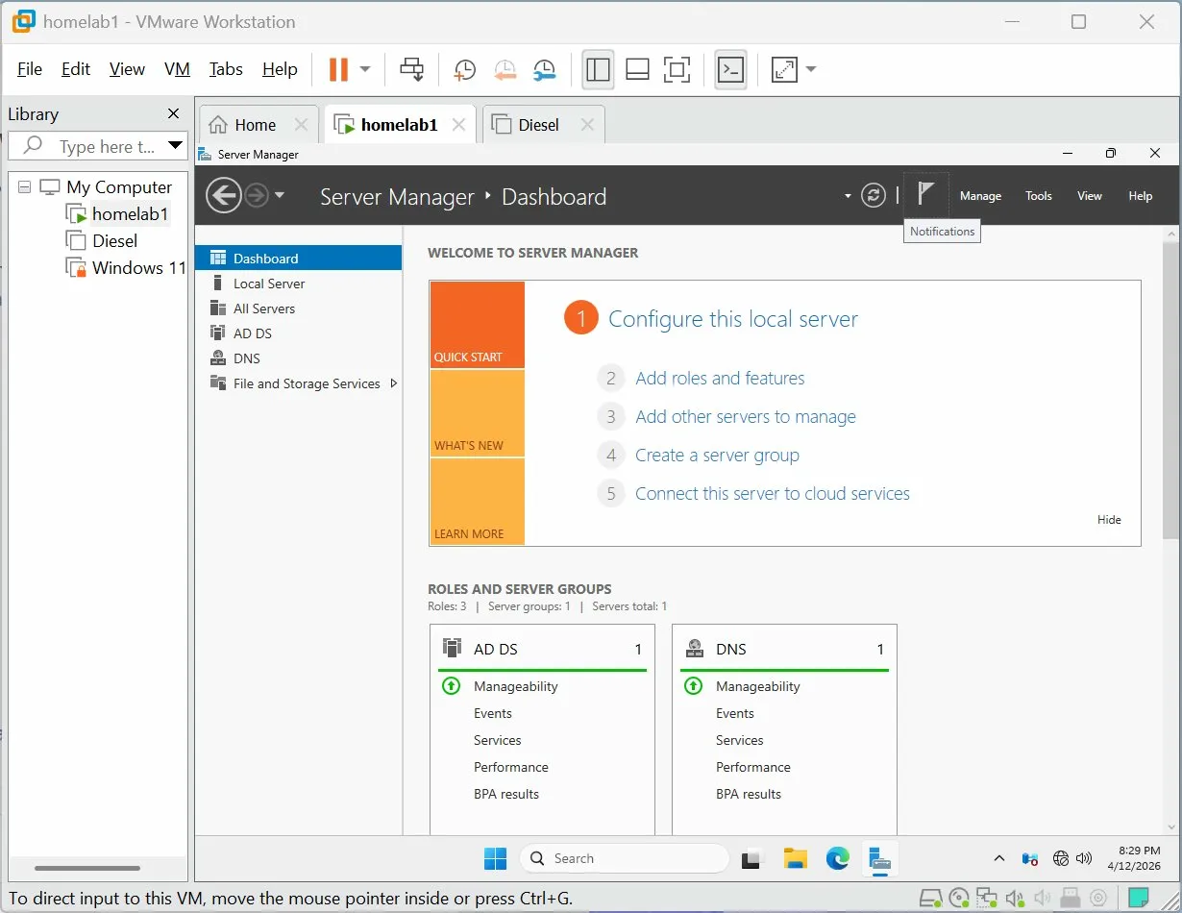
Active Directory Users and Computers showing IT_Staff OU with Alex Smith and IT Admin
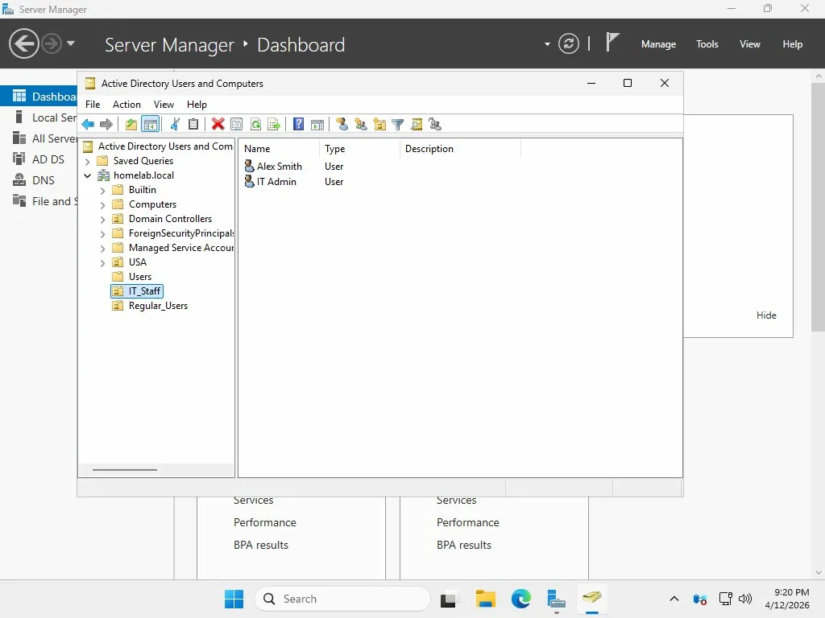
Active Directory Users and Computers showing Regular_Users OU with Bob Jones, Mike Chen, Sara Lee
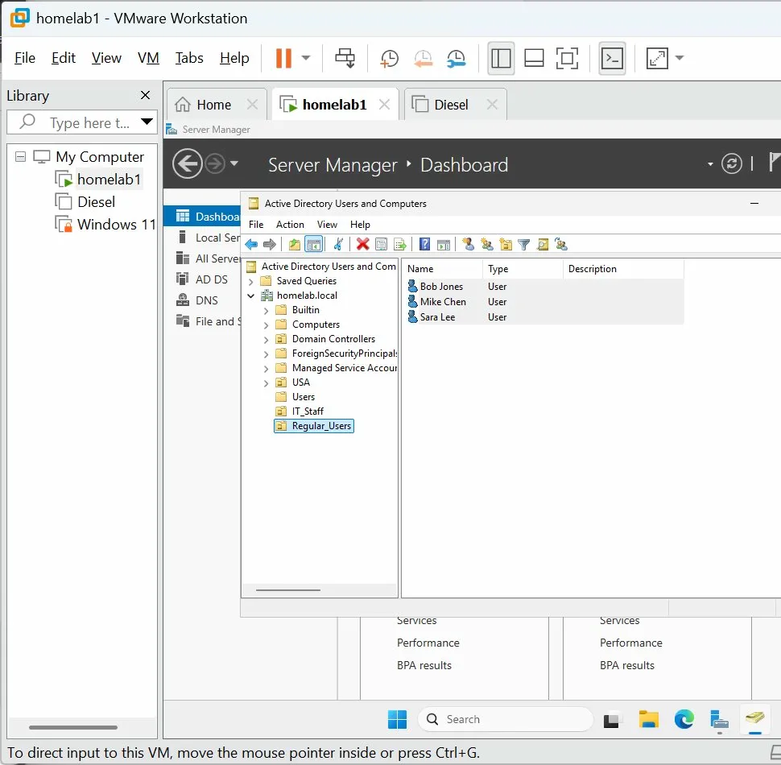
PowerShell output showing all users with their OU paths (the Get-ADUser output)
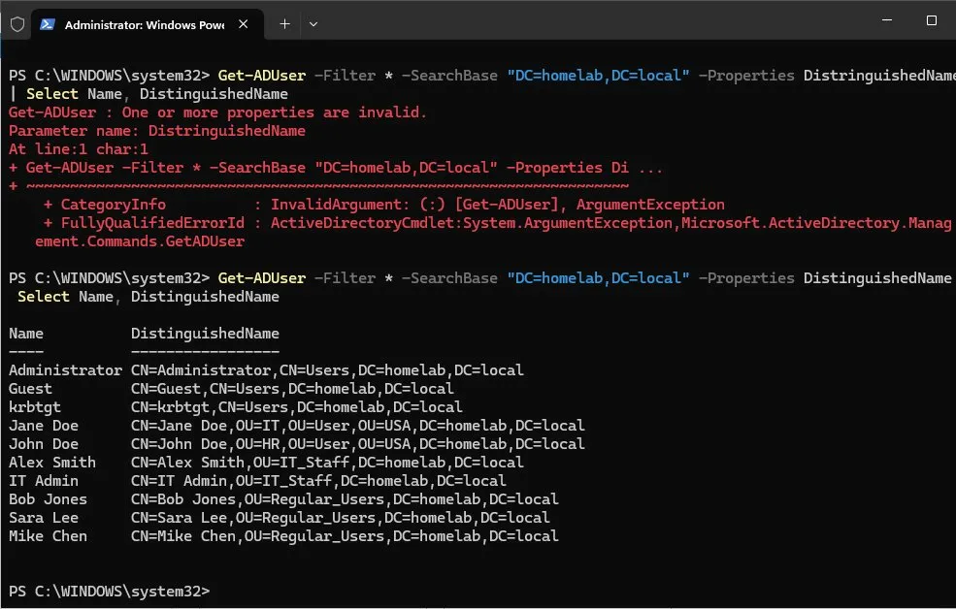
Entra ID Overview page showing Tenant ID, primary domain, Microsoft Entra ID Free license
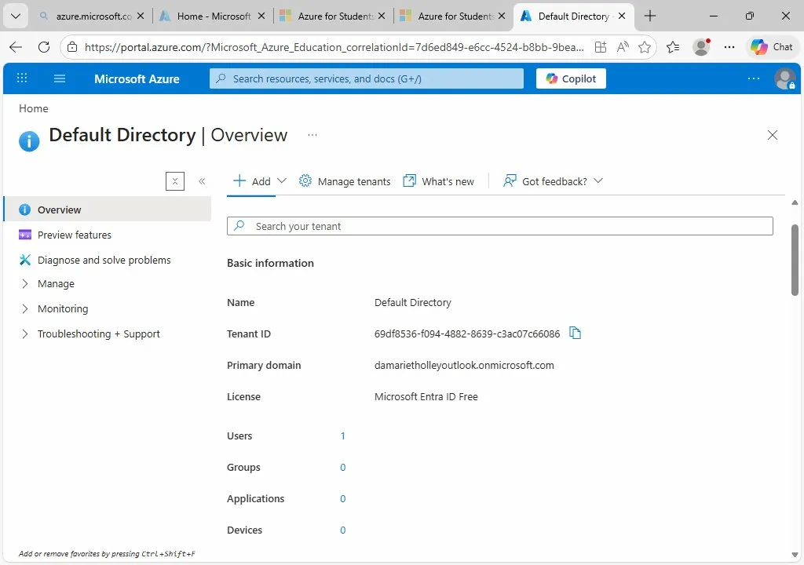
Entra ID All Users list showing all 9 users with the "On-premises sy... Yes" column visible
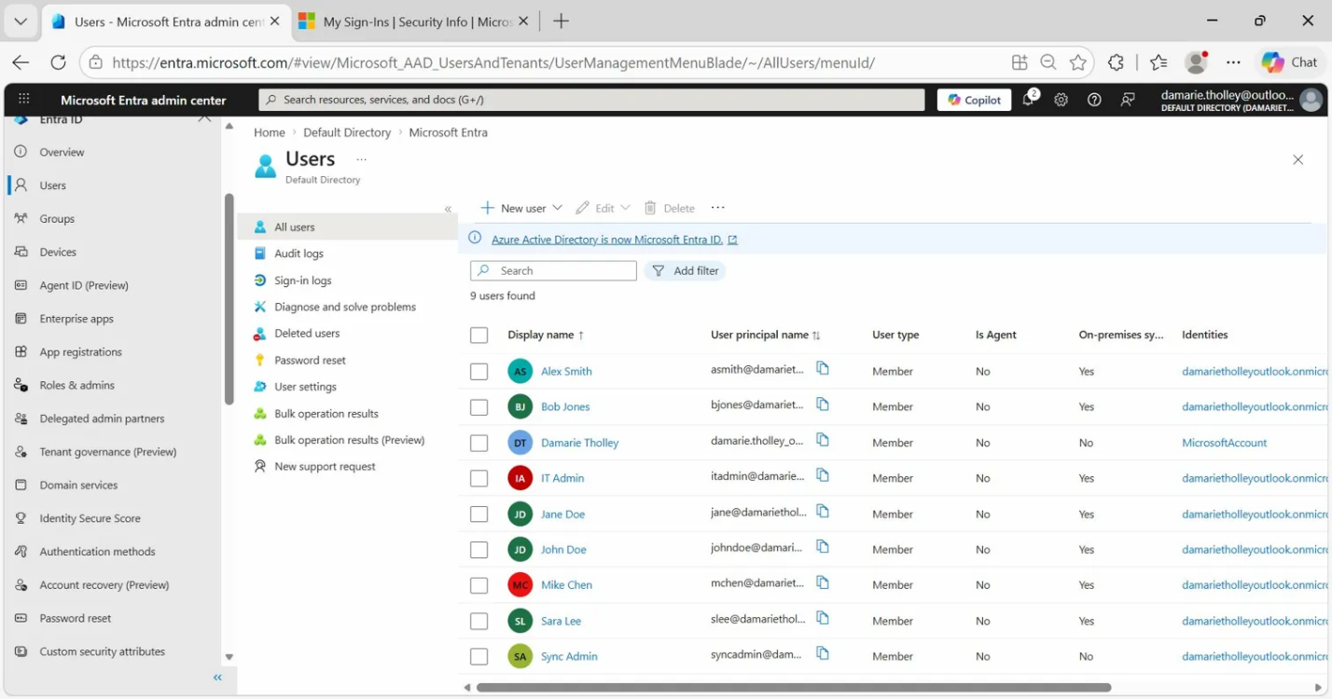
Entra Connect page showing sync is configured

